URN: 9833360 |PATIENT: HERMIONE GRANGER

DOB: 15 APRIL 2016 | PAEDS, USQ HOSPITAL

SITUATION:
Miss Hermione Granger, a 5-year-old girl, was brought in by ambulance accompanied by her mother following a collision with a car whilst riding her bicycle. The collision was at a low speed. The injuries she sustained include a suspected fracture of her left tibia and fibula, multiple grazes across her legs and feet, left hip, and shoulder. She has a 5cm laceration on her left elbow. Hermione was wearing her helmet but has sustained a small graze above her left eyebrow.

BACKGROUND
Miss Hermione Granger has no past medical and surgical histories. She lives at home with her parents and a younger brother. Miss Hermione Granger was born at 38 weeks gestation with no neonatal complications. Her immunization is up to date.

ASSESSMENT
Her Glasgow Coma Scale (GCS) is 15, moving right upper and lower limbs with mild weakness, mild weakness in left upper limb, and severe weakness in the left lower limb. Both her pupils equal and reactive to light. Her vital signs are as follows: Heart Rate 130 bpm Respiration 30 bpm Blood Pressure 120/60 mmHg SaO2 99%. She was crying due to the injuries she sustained. All blood investigations were done, and results were unremarkable. CT Trauma done and was normal (Fig 1) including her left tibia and fibula (Fig 2).

RECOMMENDATION
Continue neurological observations. Miss Hermione Granger will be kept Nil by Mouth (NBM) until she is awake. She has had IN Fentanyl STAT administered prior to CT Trauma and a second dose during the procedure. Miss Hermione Granger has analgesia prescribed as well as intravenous therapy.

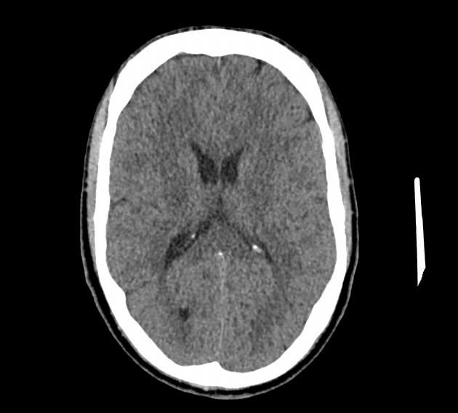

Figure 1: Ct Head

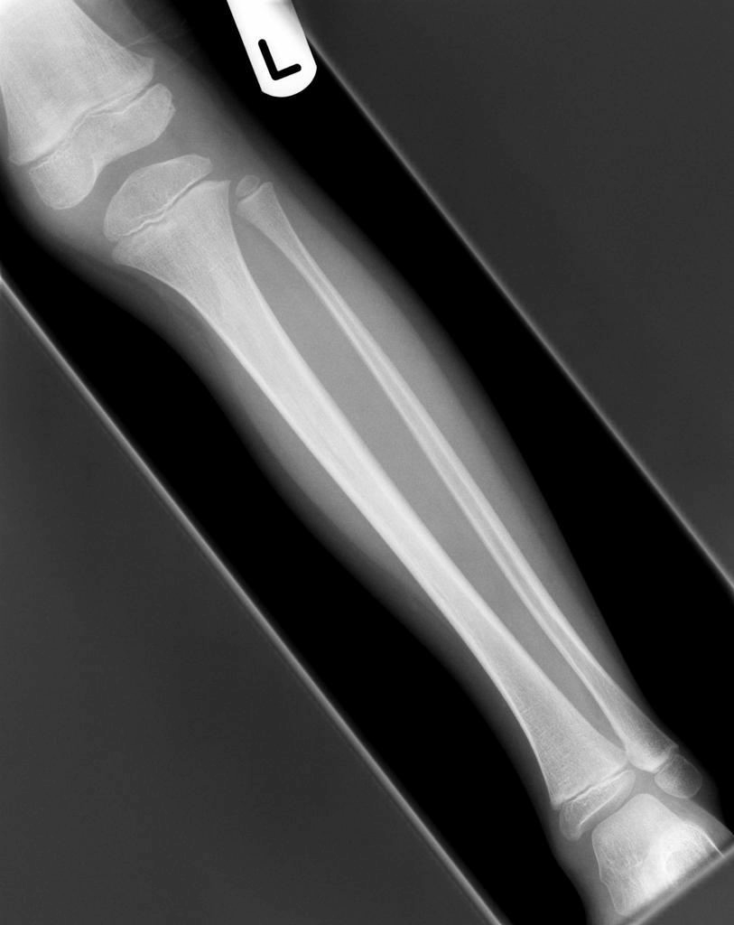

Figure 2: Left Tibia and Fibula

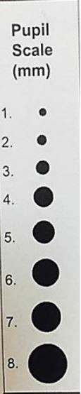
Paediatric Neurological Observation Record: Glasgow Coma Scale |  |  |  |  |  |  |  | NAME: HERMIONE GRANGER  DATE OF BIRTH: 15 APRIL 2016  URN: 9833360  GENDER: Female
A fall in GCS of 2 or more points requires review by Medical Officer |  |  | Date
 |  |  | Time
 | < 1 year | > 1 year
Eyes open | Opens spontaneously | Opens spontaneously | 4 | X | X |  |  |  |  |  | C= Eyes closed by swelling
Eyes open | Opens to voice | Opens to voice | 3 |  |  |  |  |  |  |  | C= Eyes closed by swelling
Eyes open | Opens to pain | Opens to pain | 2 |  |  |  |  |  |  |  | C= Eyes closed by swelling
Eyes open | No response | No response | 1 |  |  |  |  |  |  |  | C= Eyes closed by swelling
Best verbal response | Cues/babbles/cries appropriately | Uses appropriate words/ phrases | 5 | X | X |  |  |  |  |  | T=  Endotracheal Tube OR Tracheostomy
Best verbal response | Irritable cry/ grimace | Uses inappropriate words/ phrases | 4 |  |  |  |  |  |  |  | T=  Endotracheal Tube OR Tracheostomy
Best verbal response | Cries only to pain | Persistent crying and/ or screaming | 3 |  |  |  |  |  |  |  | T=  Endotracheal Tube OR Tracheostomy
Best verbal response | Grunts | Moans to pain | 2 |  |  |  |  |  |  |  | T=  Endotracheal Tube OR Tracheostomy
Best verbal response | No response | No response | 1 |  |  |  |  |  |  |  | T=  Endotracheal Tube OR Tracheostomy
Best motor response | Moves spontaneously | Obeys commands | 6 | X | X |  |  |  |  |  | + Reactive  - No reaction S Sluggish  C Closed
Best motor response | Withdraws to touch | Localises to pain | 5 |  |  |  |  |  |  |  | + Reactive  - No reaction S Sluggish  C Closed
Best motor response | Withdraws to pain | Withdraws to pain | 4 |  |  |  |  |  |  |  | + Reactive  - No reaction S Sluggish  C Closed
Best motor response | Abnormal flexion | Abnormal flexion | 3 |  |  |  |  |  |  |  | + Reactive  - No reaction S Sluggish  C Closed
Best motor response | Extension | Extension | 2 |  |  |  |  |  |  |  | + Reactive  - No reaction S Sluggish  C Closed
Best motor response | No response | No response | 1 |  |  |  |  |  |  |  | + Reactive  - No reaction S Sluggish  C Closed
Glasgow Coma Scale Score |  |  | 15 | 15 | 15 |  |  |  |  |  | + Reactive  - No reaction S Sluggish  C Closed
Pupils | Right | Size |  | 4 | 4 |  |  |  |  |  | + Reactive  - No reaction S Sluggish  C Closed
Pupils | Right | Reaction |  | + | + |  |  |  |  |  | + Reactive  - No reaction S Sluggish  C Closed
Pupils | Left | Size |  | 4 | 4 |  |  |  |  |  | + Reactive  - No reaction S Sluggish  C Closed
Pupils | Left | Reaction |  | + | + |  |  |  |  |  | + Reactive  - No reaction S Sluggish  C Closed
Limb movement | Arms | Normal power |  |  |  |  |  |  |  |  | Record  (R) right  (L) left Separately if there is a difference
Limb movement | Arms | Mild weakness |  | RL | RL
Limb movement | Arms | Severe weakness
Limb movement | Arms | No response
Limb movement | Legs | Normal power
Limb movement | Legs | Mild weakness |  | R | R
Limb movement | Legs | Severe weakness |  | L | L
Limb movement | Legs | No response
Fontanelle | Sunken | Dehydrated |  |  |  |  |  |  |  |  | C= Crying  √ present
Fontanelle | Soft | Normal |  | X | X |  |  |  |  |  | C= Crying  √ present
Fontanelle | Tense | Raised ICP |  |  |  |  |  |  |  |  | C= Crying  √ present
Fontanelle | Bulging | Raised ICP |  |  |  |  |  |  |  |  | C= Crying  √ present
Initial |  |  |  | LN | LN

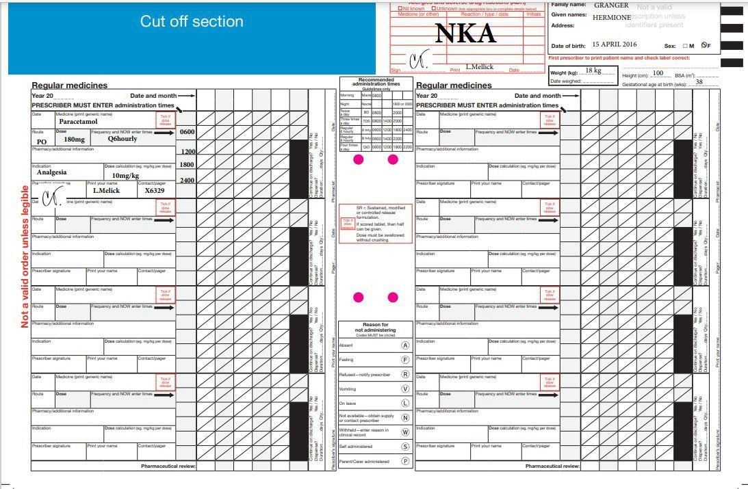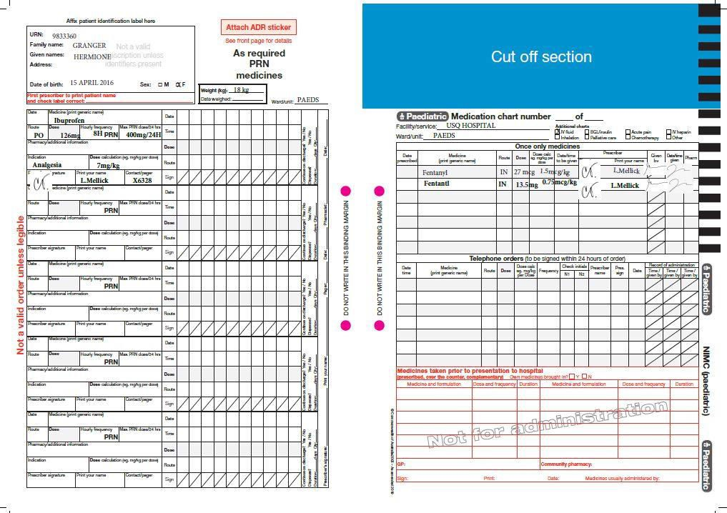

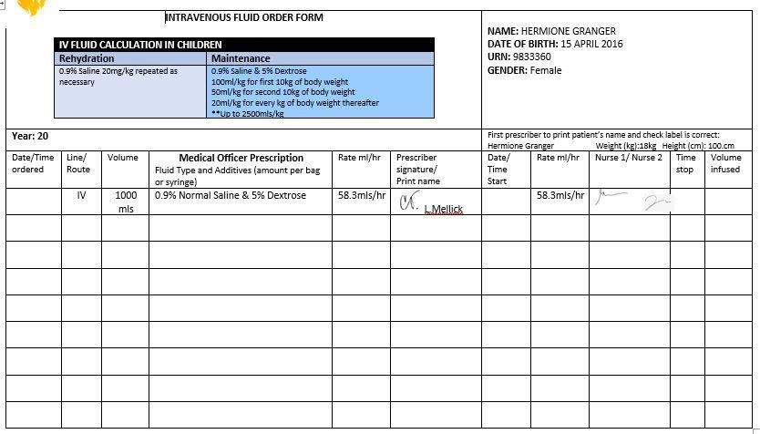

WHAT YOU NEED TO DO

- After reading the case study and reviewing all the charts in this workbook, respond to the task questions using the link below.

PRESENTATIONS REQUIREMENTS

- Question 1 to 5 must be written using formal academic sentence structure (compete paragraphs that are grammatically correct, with in-text referencing, and no dot-points, figures, or tables)

- Question 1 to 5 must be written in third person

- An introduction and conclusion paragraph are not required

- Referencing: USQ APA 7th (https://usq.pressbooks.pub/apa7/ ) and references need to be current, the last 7 years

Question 1
The initial assessment of the child’s overall condition is of crucial importance. The initial assessment of an unwell child includes the pediatric assessment triangle: appearance, breathing, and circulation to the skin; a primary survey that focuses on basic life support, patient assessment, and immediate management; secondary survey with a detailed history of the event and physical examination; and ongoing assessment. Discuss and justify with evidence-based literature one (1) reason for this (2 marks)
An unwell child presents a daunting case that calls for need of structured approach to the assessment and management of the child. One reason for the initial assessment is to identify and henceforth treat any life-threatening problems in time and in a methodical way. According to Thomas et al. ( 2016)children, even those with serious illness mostly compensate extremely well during the initial stages, which increases risks of the illness being overlooked or even underestimated by clinicians.

Question 2
Intranasal delivery has been used for several different purposes including vaccinations. Discuss and justify with evidence-based literature two (2) reasons that contraindicate the use of this route in patients (4 marks)
One of the drawbacks of intranasal delivery is that the exact routes of delivery between the nose and the brain are yet to be clearly established. According to Musumeci et al. (2019), the delivery depends on the pathways that involve the nerves that connect the nasal passages to the spinal cord and brain, as well as the lymphatic system, cerebrospinal fluid, and vasculature. One of these routes may predominate depending on the properties of the drug. Also, some mechanisms of the transport to the brain may be slow and passive affecting the effectiveness of the drug. Another reason is that the frequent intranasal delivery may damage or even irritate the mucosa (Musumeci et al.,2019). Precisely, the drugs that irritate nasal mucosa should not be delivered using the method.

Question 3
Describe and justify using peer-reviewed evidence three (3) nursing interventions that should be implemented to reduce the risk of complications to this patient (9 marks)
One of the important nursing interventions that should be administered to the patient before anything else is pain control. According to the case study, Miss Hermione Granger sustained including suspected fracture of her left tibia and fibula, multiple grazes across her legs and feet, left hip, and shoulder. The case study indicates that “ She was crying due to the injuries she sustained.” This indicates that she is in pain, and needs to administer pain medications to control the pain. This should include both pharmacological and non-pharmacological pain control interventions. The non-pharmacological pain control interventions may include positioning

Which involves proper body alignment, progressive muscle relaxation and acupuncture ( El Geziry et al., 2018). Fall prevention is also a critical nursing intervention. Fall interventions include secure locks on the bids, wheel and stretcher, keeping the patient's floor obstacle free, cleaning all the spills in the patient's room and maintaining adequate lighting Shaw et al., 2021). With the contemporary rise in fall rates, falls have become an important indicator of the quality of care and can result in exacerbation of the patient's complications (Shaw et al., 2021). Based on the involvement in the accident and the multiple injuries, the patient must be having both physiological and psychosocial pain, and therefore she needs psychological nursing intervention. The psychosocial nursing intervention includes strategies such as coping skills, stress management relapse prevention, and psychoeducation. These strategies will not only reduce the risk of complications but will facilitate the recovery process and promote patients’ mental health.

Question 4
Identify and discuss one (1) priority problem for Miss Hermione Granger during her admission to the Paediatric Ward. Justify the priority with peer-reviewed evidence (3 marks)

One priority problem for limb movement. Miss Hermione was suspected of multiple grazes across her legs and feet, left hip, and shoulder. The pediatrics report shows mild weakness in the right leg and severe weakness in the left leg as well as mild weakness in the left and right arm.

Question 5
Coping with stress reactions is common after a serious illness, injury, or hospital stay. Even though it is the child who is ill or injured, the whole family can be affected. It’s normal for the parents to feel overwhelmed trying to help the family and themself to cope. Discuss and justify with evidence-based literature three (3) nursing interventions that could help alleviate the stress experienced by parents in this situation (9 marks)

One of the nursing interventions is to talk through the experience and be educational. According to Lebel & Charette (2021), the nurse should not only talk to the parent but also offer an ear. Listening to the parent express her hears, concerns and emotions increases the chance of understanding his stress reactions and puts the nurse in a better position to help. Doupnik et al. ( 2017) further argue that communicating to them about past positive experiences, providing facts, and being considerate not only builds trust in the treatment and healing process but also assuages fears and stress. According to Li et al. ( 2016), nurses should provide as much information to the parents as possible. Even though a nurse may have quit a busy shit, securing even five minutes to talk to the parent and be as clear and educational to the parent as much as possible would greatly help. Besides, a nurse can reach out the immediate family members and the relatives or neighbors. Owing to the busy schedules and responsibilities involved in nursing care, a nurse can never be there for every parent every time. However, reaching out to the immediate people who could talk to the parent, help in the home chores and accompany the parent during the hospital visits could be highly helpful. Page (2015) points out that parent may experience resentment, stress and fatigue if she/he is responsible for doing all the visits, work and taking care of the other siblings. Having a helping hand would reduce chances of burnout and loneliness which exuberate stress levels. Since the neighbors, friends and relatives may not know how and when to help, the nurse needs to explain to them how, when and what to help to facilitate the parent's stress copping process. Nurses can also increase their patient engagements through follow up care. According to Page (2015), patient follow-up does not only increase the quality of care, but also facilitates the parent's stress coping process. A parent feels less burdened and increased hope, when she/he realizes that the nurse still cares and is concerned about the recovery of the child. Follow up gives the nurse an opportunity to assess not only the child's recovery process but also parents social-psychological health (Woods et bal., 2020). It gives an opportunity to the parent to speak out any stress related issues underlying, or help that the child or the parent needs and the nurse can be in position to advice for therapy or offer any post-care help to facilitate coping. Follow up can be done through texting, Posta mail, email or even phone calls (Lewis-Thames et al., 2020).

Reference

Doupnik, S. K., Hill, D., Palakshappa, D., Worsley, D., Bae, H., Shaik, A., Qiu, M. (., Marsac, M., & Feudtner, C. (2017). Parent coping support interventions during acute pediatric hospitalizations: A meta-analysis. Pediatrics, 140(3), e20164171. https://doi.org/10.1542/peds.2016-4171

El Geziry, A., Toble, Y., Al Kadhi, F., Pervaiz, M., & Al Nobani, M. (2018). Non-pharmacological pain management. Pain Manag Spec, 1-14.
Lebel, V., & Charette, S. (2021). Nursing interventions to reduce stress in families of critical care patients: An integrative review. Critical Care Nurse, 41(1), 32-44. https://doi.org/10.4037/ccn2021188
Lewis-Thames, M. W., Carnahan, L. R., James, A. S., Watson, K. S., & Molina, Y. (2020). Abstract A015: Post-treatment patient-provider communication and follow-up care: Does written patient-provider communication improve timely follow-up care for rural cancer survivors? Poster Presentations - Proffered Abstracts. https://doi.org/10.1158/1538-7755.disp19-a015
Li, W. H., Chung, J. O., Ho, K. Y., & Kwok, B. M. (2016). Play interventions to reduce anxiety and negative emotions in hospitalized children. BMC Pediatrics, 16(1). https://doi.org/10.1186/s12887-016-0570-5

Musumeci, T., Bonaccorso, A., & Puglisi, G. (2019). Epilepsy disease and nose-to-brain delivery of polymeric nanoparticles: an overview. Pharmaceutics, 11(3), 118.
Page, P. (2015). Critical illness trajectory for patients, families and nurses - a literature review. Nursing in Critical Care, 21(4), 195-205. https://doi.org/10.1111/nicc.12199

Shaw, L. K., Kiegaldie, D., Morris, M. E., & Jones, C. (2021). Improving hospital falls screening and mitigation using a health professional education framework. Nurse Education Today, 98, 104695.

Thomas, A. E., Baird, S. F., & Anderson, J. (2016). Purpuric and petechial rashes in adults and children: initial assessment. Bmj, 352.
Woods, C. E., Jones, R., O’Shea, E., Grist, E., Wiggers, J., & Usher, K. (2019). Nurse‐led postdischarge telephone follow‐up calls: A mixed study systematic review. Journal of Clinical Nursing, 28(19-20), 3386-3399. https://doi.org/10.1111/jocn.14951

